
COEP TECHNOLOGICAL UNIVERSITY, PUNE.
Wellesley Road, Shivajinagar, Pune-411005.

DEPARTMENT OF ELECTRONICS AND TELECOMMUNICATION ENGINEERING

Cornerstone Project Report
(SY ENTC)

Signal Encrypter using XOR Gate (RTL Logic)

Submitted by,

NAME | MIS NO.
Siddhi Kamble | 612407078
Jay Kelkar | 612407084
Tanvi Kshirsagar | 612407091

Under the Guidance of Dr. Pranav Pawar

Academic Year: 2025–2026

INDEX

Sr. No. | Title | Page No.
1 | Abstract | 1
2 | Introduction | 2
2.1 | Background | 2
2.2 | Problem Statement | 2
2.3 | Objective | 2
2.4 | Scope of Project | 3
3 | Literature Review : Impact Assessment | 4
4 | Components Used | 7
5 | Circuit Diagram : LTspice Schematic | 8
6 | Design and Calculations | 9
6.1 | Design Approach | 9
6.2 | Assumptions | 9
6.3 | Calculations | 9-10
6.4 | XOR Truth Table | 10
6.5 | Q-Point Analysis | 11
6.6 | Transistor State Table | 11
7 | Result and Discussion | 12
7.1 | Simulation Results | 12
7.2 | Breadboard Implementation | 13
7.3 | PCB Implementation | 13-14
8 | Conclusion and Summary | 15
9 | References | 16

ABSTRACT

In the modern digital era, secure communication has become essential due to the increasing transmission of sensitive information over various networks. Encryption techniques are widely used to protect data from unauthorized access. This project presents the design and implementation of a signal encrypter using XOR (Exclusive OR) logic realized through discrete transistor-based RTL circuitry.

The XOR gate is widely used in encryption systems due to its reversible property. In this project, instead of using standard ICs such as 7486, the XOR gate is implemented using 2N2222 NPN transistors. The design process began with theoretical analysis and calculation of resistor values and transistor operating currents to ensure proper switching between cutoff and saturation regions.

The circuit was simulated using LTspice software to verify its functionality. The simulation results confirmed that the output follows the XOR truth table. After successful simulation, the circuit was implemented on a breadboard for practical verification and later transferred onto a zero PCB through soldering.

The final hardware setup successfully demonstrated signal encryption using XOR logic, where the output depends on the combination of message and key inputs. This project provides a strong understanding of digital logic design, transistor switching behaviour, and practical hardware implementation.

INTRODUCTION

- Background
In today’s digital communication systems, ensuring data security has become extremely important. Information transmitted over communication channels is prone to interception, making encryption a necessary tool to maintain confidentiality. Encryption converts readable data into an encoded form that can only be decoded using a specific key.

Among various digital logic techniques, the XOR (Exclusive OR) gate plays a vital role in encryption systems. Its unique property of producing a high output only when inputs differ makes it suitable for secure data encoding and decoding.
In this project, instead of using a ready-made IC like 7486, the XOR logic is implemented using discrete NPN transistors. This approach provides a deeper understanding of transistor-level circuit design and the internal functioning of logic gates using RTL (Resistor-Transistor Logic).

- Problem Statement
Most basic digital systems transmit signals without encryption, making them vulnerable to unauthorized access. Although advanced encryption techniques exist, they often require complex hardware and software.

The problem addressed in this project is to design a simple and efficient hardware-based encryption system using basic components.
The goal is to implement an XOR-based signal encryptor using discrete transistors, ensuring proper operation through theoretical calculations, simulation, and practical implementation.

- Objective
The main objectives of this project are:
- To design an XOR gate using discrete NPN transistors.
- To implement a signal encrypter using XOR logic.
- To calculate resistor values and transistor currents for proper operation.
- To verify the circuit using LTspice simulation.
- To implement the circuit on a breadboard and zero PCB.
- To understand transistor switching behaviour in digital circuits.
- Scope of Project
This project focuses on the complete development cycle of a signal encrypter circuit, including design, analysis, simulation, and hardware implementation.
The scope includes:
- Transistor-level implementation of XOR logic.
- Calculation of operating parameters such as current and voltage.
- Simulation using LTspice.
- Practical implementation on breadboard.
- Final hardware realization using zero PCB.

Our primary focus was the bitwise encryption of signal using a secret key(shared) and a binary message signal.

LITERATURE REVIEW

Digital logic circuits form the foundation of modern electronic systems, particularly in communication, computing, and embedded applications. Among the various logic gates, the XOR (Exclusive OR) gate holds significant importance due to its unique logical behaviour and wide range of applications in digital systems such as encryption, error detection, arithmetic operations, and data transmission.

The XOR operation is mathematically expressed as:
$$Y=A⊕B=A^{'}B+AB^{'}$$

which was initially same as:
$$Y=A⊕B=(A+B)(AB)'$$
This logical expression indicates that the output is HIGH only when the inputs are different. One of the most important characteristics of the XOR operation is its reversibility, which makes it highly suitable for encryption and decryption processes.

When a message signal is XORed with a key signal, the output becomes encrypted. Applying the same XOR operation again with the same key restores the original signal, as applying XOR twice with the same key restores the original data. This fundamental concept is widely used in symmetric cryptographic systems and digital communication protocols.

Impact Assessment

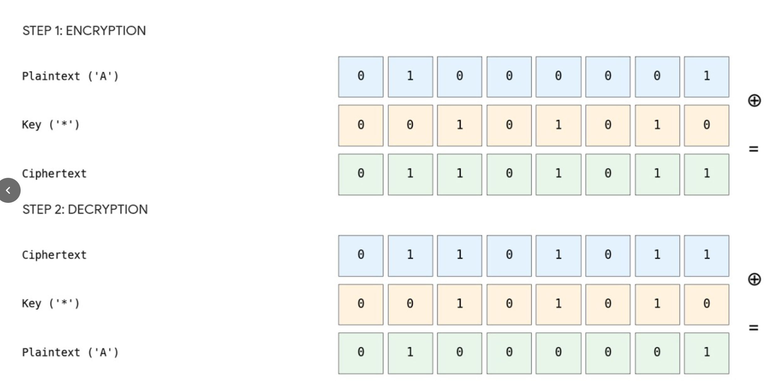
Traditionally, XOR gates are implemented using integrated circuits such as the RTL-based IC 7486 or CMOS equivalents. These ICs provide compact and reliable implementations but abstract away the internal working of the logic. In contrast, implementing logic gates using discrete components such as bipolar junction transistors (BJTs) provides deeper insight into circuit behaviour, switching characteristics, and design principles.

Transistor-level design helps in analysing:
- Switching characteristics of devices.
- Current flow and voltage levels.
- Logic level transitions.
- Power dissipation and efficiency.

Proper biasing ensures that transistors avoid the active region and behave like ideal switches, which is essential for digital circuit reliability.

In Resistor-Transistor Logic (RTL), BJTs are used as the primary switching elements. The operation of RTL circuits relies on transistors functioning in two distinct regions:
- Cutoff Region → No conduction (logic LOW)
- Saturation Region → Full conduction (logic HIGH/LOW depending on configuration)

Avoiding operation in the active region is essential for ensuring fast switching and reliable digital performance. To achieve this, proper biasing is required, which involves selecting suitable resistor values to control base current ($I_{B}$) and collector current ($I_{C}$).

A key concept in transistor switching design is the use of forced beta ($β_{forced}$), which ensures that the transistor enters saturation under all input conditions. This improves switching reliability and minimizes uncertainty due to variations in transistor gain.

Several standard textbooks, such as those by Kulshreshtha [1], Kothari and Nagrath [2], and Hughes [3], emphasize the importance of transistor-level circuit analysis for understanding digital electronics. These works highlight how resistor selection, voltage levels, and current flow determine the behaviour of logic circuits.

With the advancement of simulation tools, software such as LTspice has become an essential part of circuit design. Simulation allows engineers to verify logical operations, analyse voltage waveforms, and optimize circuit parameters before physical implementation. It reduces design errors and improves efficiency in developing reliable circuits.

In this project, the XOR gate is implemented using discrete NPN transistors (2N2222) instead of standard ICs. The design process involves theoretical calculations, simulation verification, and practical implementation on breadboard and zero PCB. This approach not only demonstrates the working of XOR-based encryption but also provides hands-on understanding of transistor switching and hardware realization.

This begs the question, how does XORing message with the key lead to the message being encrypted? Now, on the transmitter side, the message signal A is bitwise XORed with message signal B and on the receiver’s side, the encrypted output from the transmitter is again XORed with the output, yielding the original
message signal.

Thus, the project integrates concepts from digital logic design, transistor theory, and basic cryptography, making it a comprehensive study of hardware-based signal encryption.

COMPONENTS USED

1. | NPN Transistors (2N2222) | Used for implementing XOR logic
2. | Resistors (1k$Ω$, 10k$Ω$, 470$Ω$) | For biasing and current control
3. | Power Supply (5V DC) | RTL logic levels
4. | Input Sources (V_{A}, V_{B}) | Message and key inputs
5. | LED | Output indication
6. | Male to Male cables | Circuit Connections
7. | Solder wire | Soldering Connections
8. | Switches | Switching between VCC & GND
9. | Breadboard | Temporary implementation
10. | Zero PCB | Final soldered circuit
11. | Simulation Software (LTspice) | Circuit verification

CIRCUIT DIAGRAM

The circuit consists of multiple transistor stages forming the XOR logic. Each transistor acts as a switch controlled by input signals. Based on the input combination, specific transistors turn ON or OFF, resulting in the desired XOR output.

- LTspice Schematic

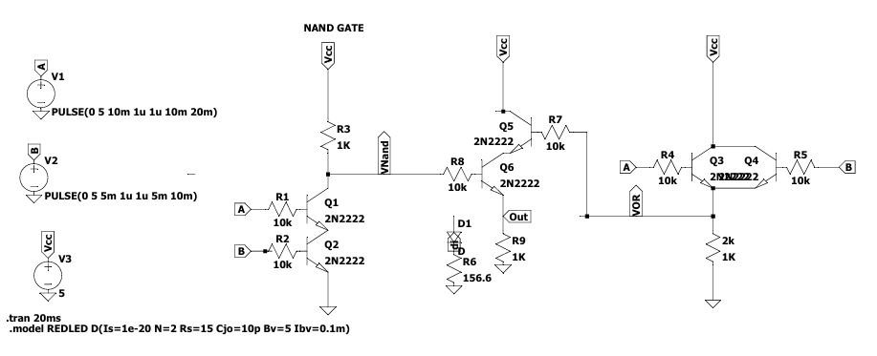

DESIGN AND CALCULATIONS

- Design Approach
The XOR gate required for the signal encrypter is implemented using discrete NPN transistors (2N2222) operating in switching mode (saturation region).

The design is based on RTL logic levels where:
- Logic HIGH = 5V
- Logic LOW = 0V

Each transistor acts as a switch:
- Cutoff region → OFF state (logic 0)
- Saturation region → ON state (logic 1)

The circuit combines multiple transistor stages to achieve XOR functionality.
The circuit essentially combines an OR gate, an AND gate, and a NAND gate, to create XOR gate.

- Assumptions and Parameters
- Supply Voltage, $V_{CC}=5V$
- Collector current (assumed), $I_{C}=4.8mA$
- Saturation voltage, $V_{CE(sat)}=0.2V$
- Base-emitter voltage, $V_{BE}=0.7V$
- Current gain, $β=100$
- Forced beta (switching), $β_{forced}=10$

- Collector Resistor Calculation
Using KVL in collector circuit:

$$R_{C}=\frac{V_{CC}-V_{CE(sat)}}{I_{C}}$$
$$R_{C}=\frac{5-0.2}{4.8mA}=\frac{4.8}{0.0048}= 1kΩ$$
$$R_{C}=1.0kΩ (standard value 1.0kΩ selected)$$
- Base Current Calculation
$$I_{B}=\frac{I_{C}}{β_{forced}}=\frac{4.8mA}{10}=0.48mA$$

- Base Resistor Calculation
Using KVL:
$$R_{B}=\frac{V_{IN}-V_{BE}}{I_{B}}$$
$$R_{B}=\frac{5-0.7}{0.48mA}=\frac{4.3}{0.0048}= 9kΩ$$

$$R_{B}≈10kΩ (standard value)$$

Recalculating the I_{B} for R_{B} = 10k,
I_{B} = 0.43mA

Hence, $β_{forced}$changes to:

$\frac{4.8mA}{0.43mA}$ $≈$ 11.16
which is well below the active region current gain.

- XOR Truth Table

Input A | Input B | Output Y (A ⊕ B)
0 | 0 | 0
0 | 1 | 1
1 | 0 | 1
1 | 1 | 0

- Q-Point Table (Q-Point sures that transistors operate only in cutoff and saturation regions, avoiding the active region, which is necessary for proper digital switching)

A | B | Output | Region | $$I_{C}$$ | $$V_{CE}$$
0 | 0 | 0 | Saturation | 4.8mA | 0.2V
0 | 1 | 1 | Cutoff | 0 | 5V
1 | 0 | 1 | Cutoff | 0 | 5V
1 | 1 | 0 | Saturation | 4.8mA | 0.2V

- Transistor State Table

A | B | Q1 | Q2 | NAND O/P | Q6 | Q3 | Q4 | Q5 | Output | $$Description$$
0 | 0 | OFF | OFF | HIGH | OFF | OFF | OFF | OFF | 0 | No conduction to O/P
0 | 1 | OFF | ON | HIGH | ON | OFF | ON | ON | 1 | Current flows- LED ON
1 | 0 | ON | OFF | HIGH | ON | ON | OFF | ON | 1 | Current flows- LED ON
1 | 1 | ON | ON | LOW | OFF | ON | ON | OFF | 0 | Path broken – Q6 OFF

- Power Dissipation (Total circuit)
$$P=V_{CC}×Ic \\ P=5×3×4.8mA=72mW$$

- Transistor Switching Summary
  - Cutoff → Transistor OFF → Output HIGH
  - Saturation → Transistor ON → Output LOW

Thus, the circuit behaves as a digital XOR gate.

RESULT AND DISCUSSION

- Truth Table:
V_{A} | V_{B} | Output Y (A ⊕ B)
0 | 0 | 0
0 | 1 | 1
1 | 0 | 1
1 | 1 | 0

- Working Steps Followed:
- Designed circuit based on XOR logic.
- Calculated resistor values and currents.
- Simulated in LTspice.
- Verified output waveform.
- Implemented on breadboard.
- Transferred to zero PCB through soldering.

- Simulation Output Waveforms:

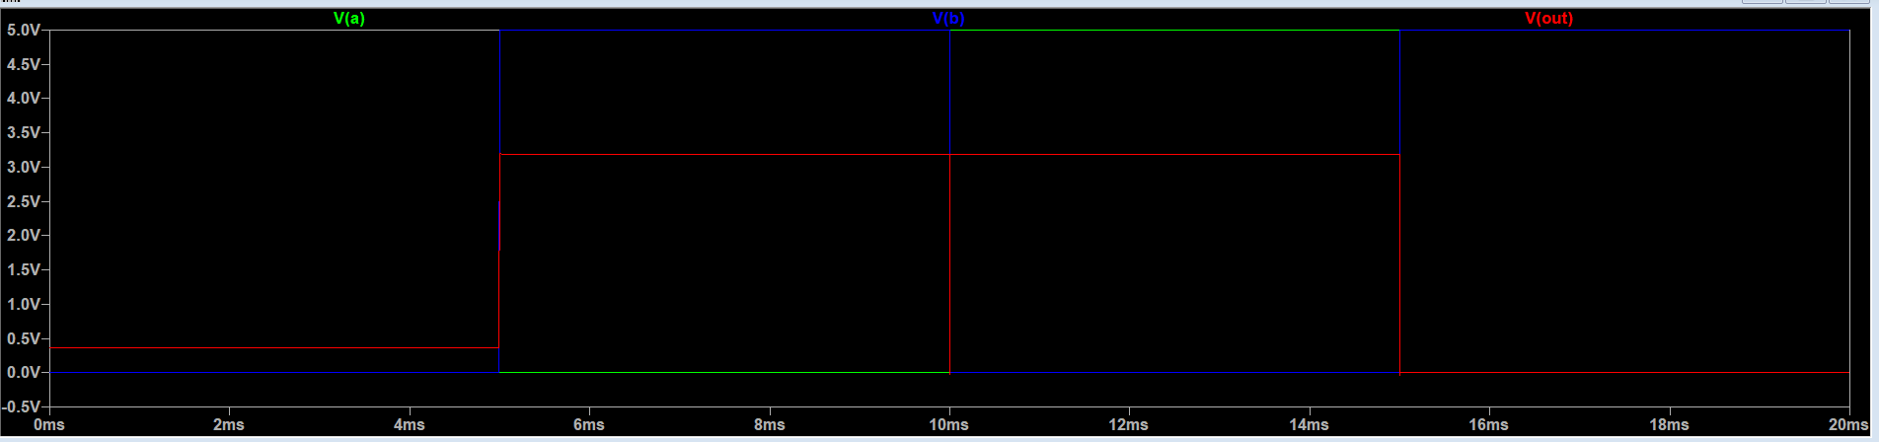
- Breadboard Implementation:

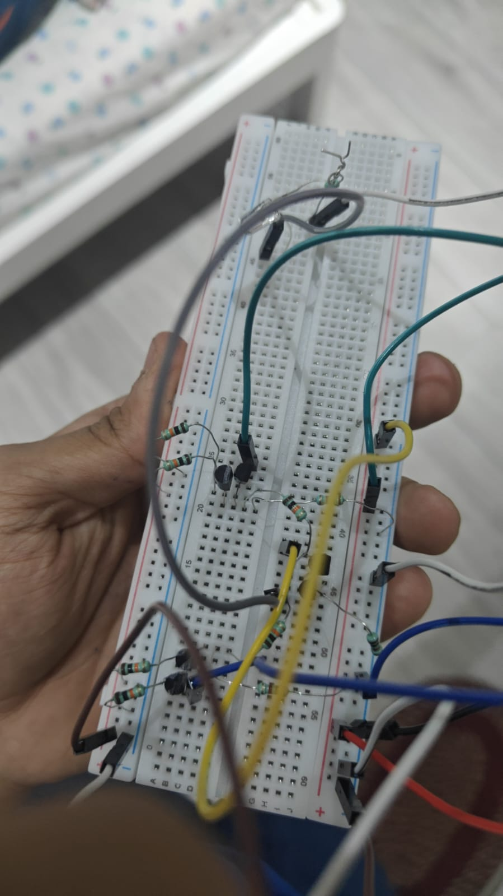

- Zero PCB (Final Hardware):

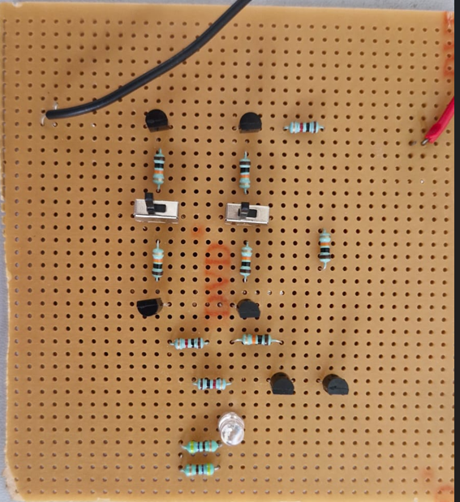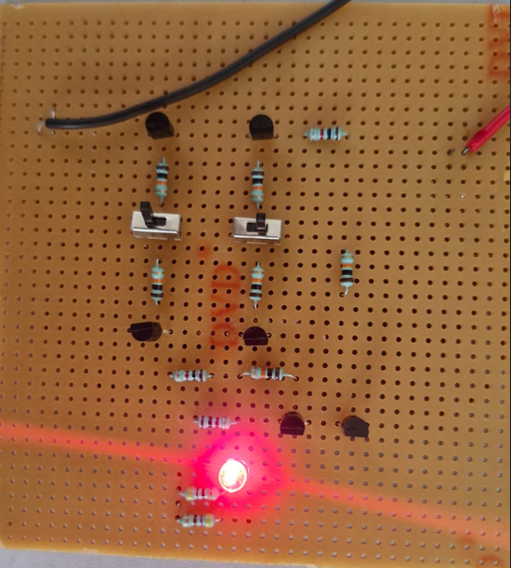
1. Output state for binary inputs 00 2. Output state for binary inputs 01
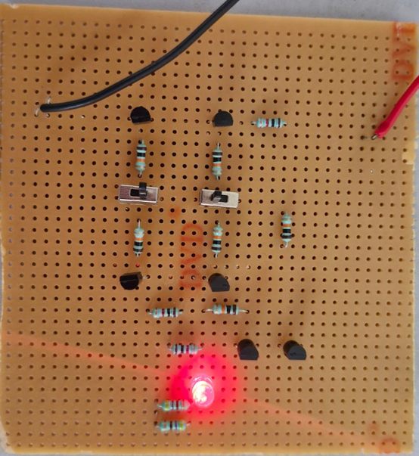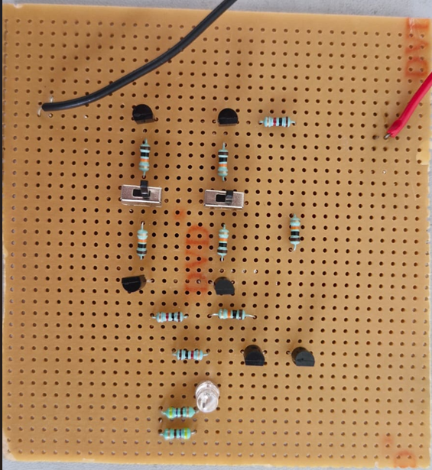
3. Output state for binary inputs 10 4. Output state for binary inputs 11

- Observations:
- Output matches XOR logic.
- Transistors operate in switching mode.
- No active region operation.

- Discussion:
- Simulation matched theoretical results.
- Transistors operated in switching regions.
- Output correctly followed XOR logic.
- Hardware implementation validated design.

CONCLUSION AND SUMMARY

The signal encrypter using XOR logic was successfully designed and simulated using discrete transistor-based RTL circuitry.

The project demonstrated how basic encryption can be achieved using simple digital logic.

The XOR gate was implemented using NPN transistors, and its behaviour was verified through simulation. The output matched the expected truth table, confirming correct operation.

This project provided valuable insights into:
- Digital logic design.
- Transistor switching behaviour.
- Basic encryption techniques.

Overall, the project serves as a foundation for understanding more advanced encryption systems and digital circuit design.

REFERENCES

- LTspice Manual https://LTspice.analog.com/software/LTspice64.msi
- Digital Electronics & Electronic Devices Notes
- Initial circuitry researchgate.net
- The BJT Transistor 2N2222 Datasheet

